RESOLUTION NO.__________

RE: CERTIFICATE OF APPROPRIATENESS UNDER THE
PROVISIONS OF THE ACT OF THE PENNSYLVANIA
LEGISLATURE 1961, JUNE 13, P.L. 282 (53
SECTION 8004) AND BETHLEHEM ORDINANCE NO.
3952 AS AMENDED.

WHEREAS, it is proposed to replace windows, re-roof the rear portion of the house and re-stucco areas on the front and rear of the house at 328 Polk Street.

NOW, THEREFORE, BE IT RESOLVED by the Council of the City of Bethlehem that a Certificate of Appropriateness is hereby granted for the work.

Sponsored by: (s)

(s)

ADOPTED BY COUNCIL THIS DAY OF

(s)
President of Council

ATTEST:

(s)
City Clerk

HISTORIC CONSERVATION COMMISSION

CASE # 530 – It is proposed to replace windows, re-roof the rear portion of the house and re-stucco areas on the front and rear of the house at 328 Polk Street
OWNER/APPLICANT: Rymar Properties LLC / Ryan Stawasz

The Commission upon motion by Mr. Roeder seconded by Mr. Evans adopted the proposal that City Council issue a Certificate of Appropriateness for the proposed work described herein:

- The proposal to replace windows, re-roof the rear portion of the house and re-stucco areas on the front and rear of the house at 328 Polk Street was presented by Ryan Stawasz.

- The current white vinyl windows, damaged by a fire, will be replaced with new 2/2 vinyl double hung windows to fit the size of the existing window openings as closely as possible.

- On the enclosed front porch three equal double hung windows will be installed in the large window opening on left side of the porch.

- On the front façade of the three story house, the infilled upper left window will be reopened and a new window installed.

- The roof of the rear shed roofed addition will be raised approximately 2’- 3’ as shown in the drawings supplied and as discussed at the meeting.

- The new roofing on the shed roof will be GAF Slateline shingles in the Antique Slate color.

- The rear addition soffit and fascia will be painted wood, solid PVC material, or vinyl.

- The damaged brickote on the main house will be patched and brickote to match the existing will be used on the rear structure where the roof is being raised. The new brickote will match the existing as closely as possible in color and texture.

- The front porch stonecote finish will be covered with sand-smooth stucco if possible. The smooth stucco should have no discernible texture.

- The existing satellite dishes will be removed.

- The proposed motion was unanimously approved.

CU: cu
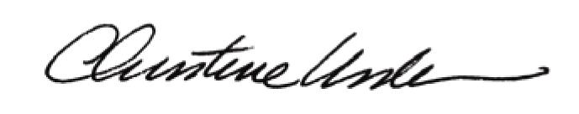

By:

Date of Meeting: February 18, 2015 Title: Historic Officer

